**Lab 3 HTTP in Action**

**Tasks to complete:**

1. Complete Lab 3 HTTP in Action. Follow the example at the end of the document to see how and what to capture for this lab.

**Using the Developer Tools**

Most modern browsers include a set of Developer Tools designed to provide a detailed look into your browser’s activity. It is possible to monitor the traffic of HTTP requests and responses associated with a web page in real time.

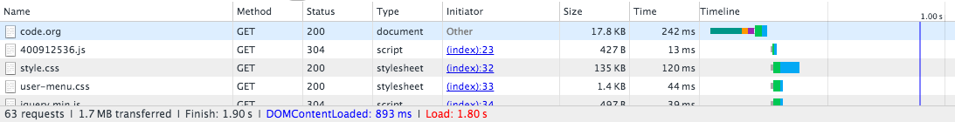

Use the links below to help you navigate to the **Developer Tools** of your browser. In Chrome, Internet Explorer and Firefox you’ll need to **open the “Network” tab.**

Chrome: <https://developers.google.com/web/tools/chrome-devtools/>

Internet Explorer: <https://msdn.microsoft.com/library/bg182326(v=vs.85)>

Firefox: <https://developer.mozilla.org/en-US/docs/Tools/Network_Monitor>

Safari: <https://developer.apple.com/safari/tools/> (look at the “Network Requests” in the “Timelines” tab.)

**Seeing HTTP in Action**

You will use your browser’s developer tools to discover what kind of HTTP traffic is associated with visiting different types of websites. You and your partner are going to look at least 5 different types of websites:

1. [http://example.com](https://example.com) -- a very simple web page. Use this first to investigate developer tools.
2. **A “static” website** like: Wikipedia
3. **A news website** like: ESPN.com, BuzzFeed, the New York Times, etc.
4. **A streaming site** like: YouTube, or Spotify
5. **A site that accepts user input** like: twitter, facebook, email, google docs.

For each type of website, follow these steps:

1. Monitor the HTTP traffic generated by loading the page.
2. Once the page has loaded, poke around with the other information the developer tools let you see about the data coming in. What can you see about the protocols?
3. Interact with the website by clicking links or using other functionality on the site, noting how this affects the HTTP traffic.
4. **Capture 2 screens from 4 sites and answer the following questions**. Example.com is done for you.

|  |  |
| --- | --- |
| Total amount of data received |  |
| Number of HTTP requests actually generated by loading one page |  |
| Total time to load the page and Method(s) |  |
| Types of data received through HTTP (it’s more than just HTML) |  |

Example

1 <http://example.com> -- a very simple web page. Use this first to investigate developer tools.

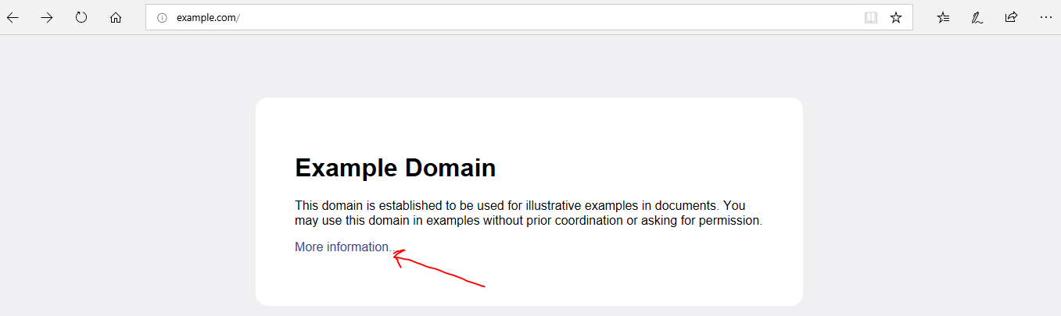

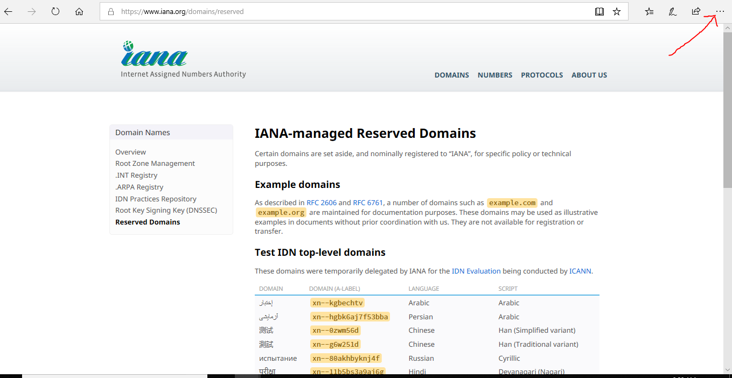

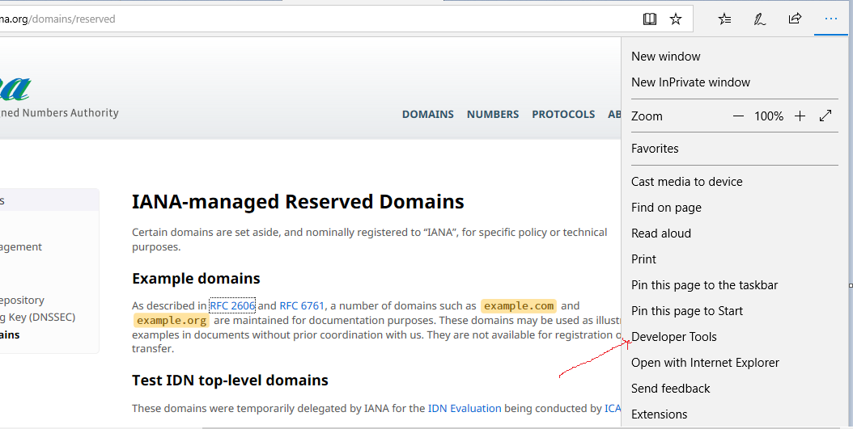

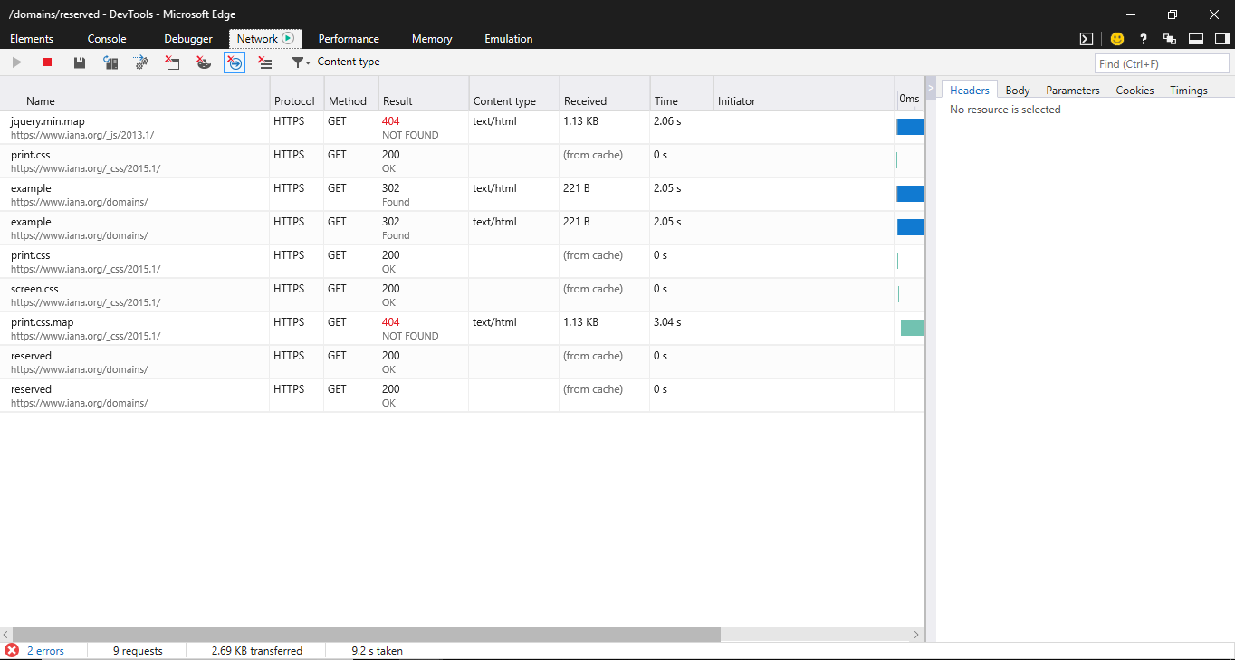

|  |  |
| --- | --- |
| Total amount of data received | 260 KB |
| Number of HTTP requests actually generated by loading one page | 9 |
| Total time to load the page and Method(s) | 9.2, GET |
| Types of data received through HTTP (it’s more than just HTML) | Text/HTML |
|  |  |

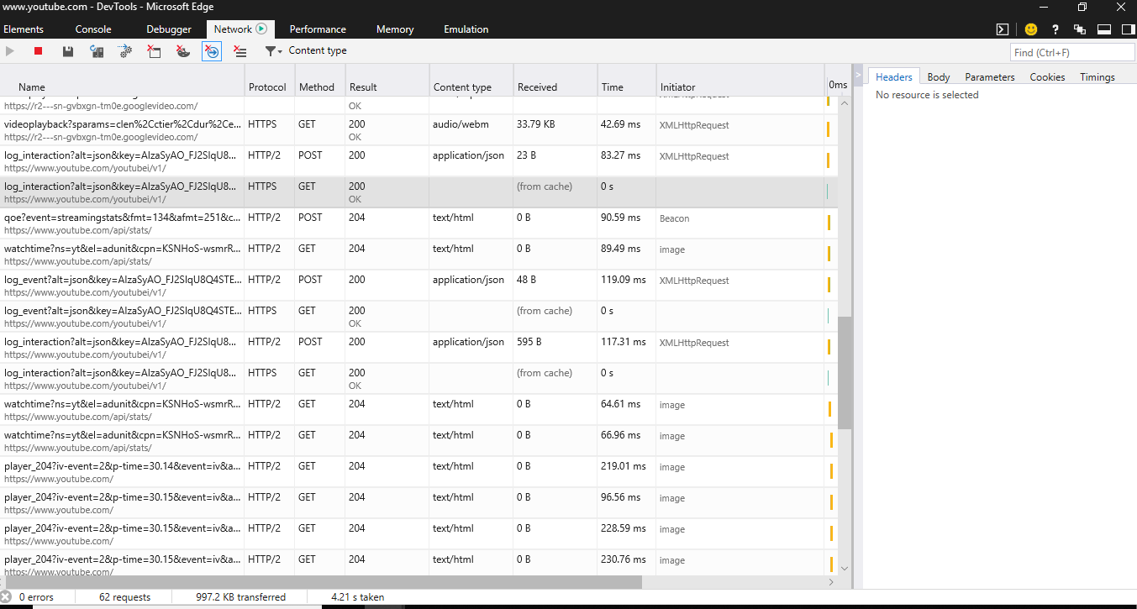

|  |  |
| --- | --- |
| Total amount of data received | 997.2 KB |
| Number of HTTP requests actually generated by loading one page | 62 |
| Total time to load the page and Method(s) | 4.26 s, GET and POST |
| Types of data received through HTTP (it’s more than just HTML) | Text/HTML,  application/json,  Audio/ Webcam,  image etc. |

Rubric of Tasks in week 3

|  |
| --- |
| **Criteria** | **Un(satisfactory)** | **Good** | **Excellent** |
| **Identifies activities while making HTTP request** | **0 to .5 point**  Identifies a limited number of required activities making HTTP request/response. | **.5to 1.0 points**  Identifies a considerable number of required activities making HTTP request/response. | **1 to 1.5 points**  Identifies almost all of required activities making HTTP request/response. |
| **Associated activities:**  **Completing KWL,**  **Report on 3 Tier Architecture** | **0 to .5 point**  Did not complete KWL chart |  |  |
| **Knowledge and Understanding of 3 Tier Architecture** | **0 to .5 point**  **Report demonstrates some understanding of 3 Tier Architecture and is somewhat difficult to understand** | **.5 to 1.0 point**  **Report demonstrates excellent understanding of 3 Tier Architecture and is very easy to understand** |  |